Case 5-Asia-China-Hongshan-Dragon-Pendant-Jade-4700 to 2900 BCE
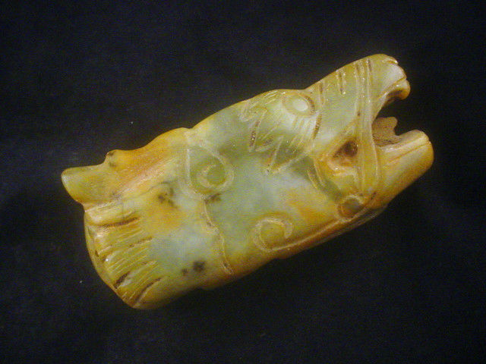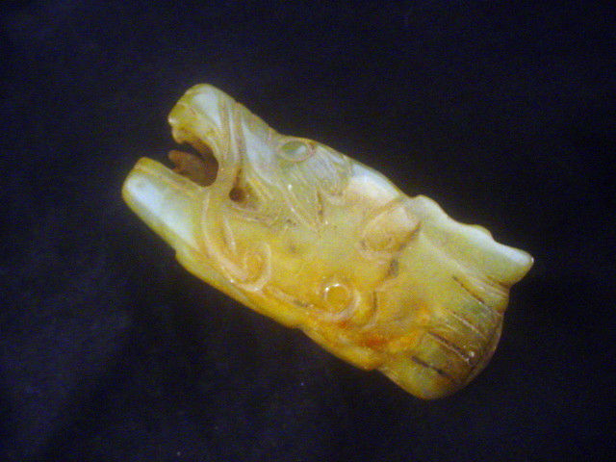
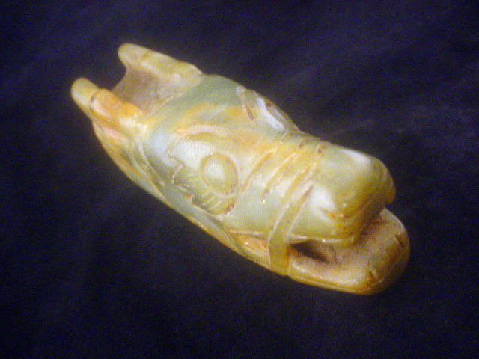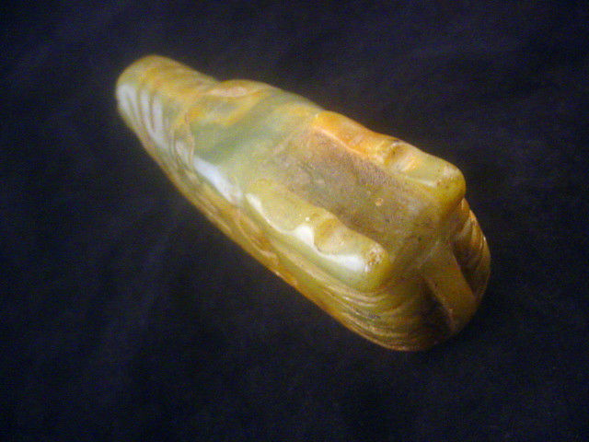

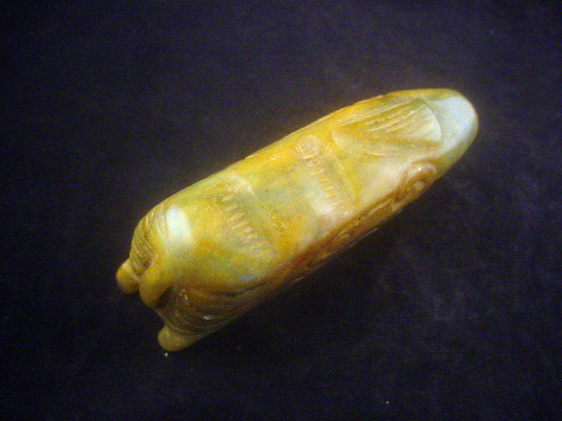
Asia-China-Hongshan-Dragon-Pendant-Jade-4700 to 2900 BCE

Case No.: 5
Accession Number:
Formal Label: Asia-China-Hongshan-Dragon-Pendant-Jade-4700 to 2900 BCE
Display Description:
This unusual Hongshan culture (紅山文化) jade head of a dragon may have been from the Liao river basin. It is of a different style from the so-called “pig dragon” designs of Hongshanhou, a site in Hongshan District, Chifeng, which was discovered by the Japanese archaeologist Torii Ryūzō in 1908 and excavated in 1935 by Kōsaku Hamada and Mizuno Seiichi (Hamada 1938).
LC Classification:
Date or Time Horizon:
Geographical Area: NE of Beijing
Map:
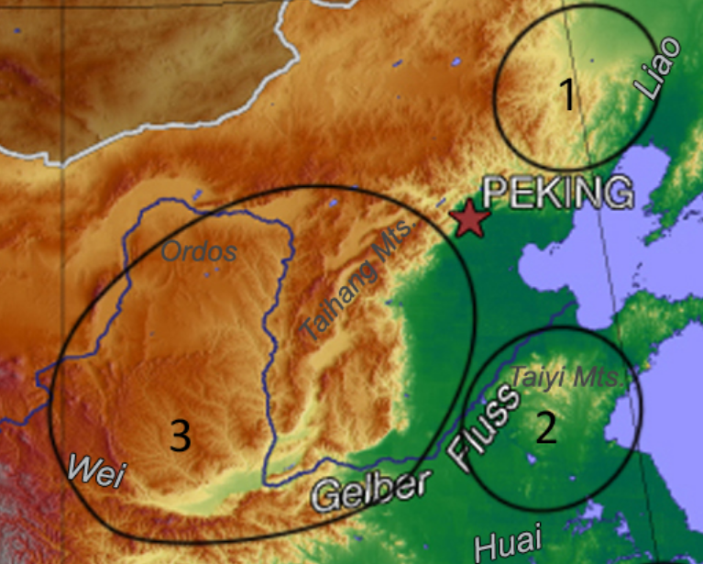
Map of 1. Hongshan, 2. Dawenkou and 3. Yangshao.
After https://upload.wikimedia.org/wikipedia/commons/8/86/China%2C_middle_Neolithic_cultures.jpg
GPS Coordinates:
Cultural Affiliation:
Medium:
Dimensions:
Weight:
Provenance:
Condition:
Discussion:
References:
Hamada, Kosaku and Mizuno Seiichi. "Chifeng Hongshanhou," Archaeologia Orientalis, ser. A, No. 6. Far-Eastern Archaeology Society of Japan, (1938).
Appendix:
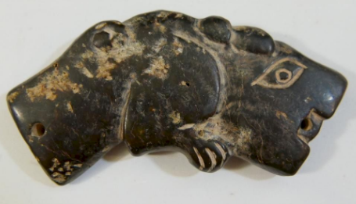
ANTIQUE CHINESE JADE TIGER PENDANT - SHANG DYNASTY by Capitoline Auction Gallery | which is similar in head design to the present example.
SHAPE \* MERGEFORMAT 